**LAB # 06**

**AC SUPERPOSITION**



SUBMITTED BY: **Aimal Khan**

REG NO: **21PWCSE1996**

SECTION: **“A”**

SUMITTED TO: **Engineer Faiz Ullah Sir**

**UNIVERSITY OF ENGINEERING AND TECHNOLOGY PESHAWAR**

**COMPUTER SYSTEM ENGINEERING**

**ASSESSMENT RUBRICS**

|  |  |  |  |  |  |
| --- | --- | --- | --- | --- | --- |
|  | LAB REPORT ASSESSMENT | | | | |
|  | Criteria | Excellent | Average | Nil | Marks Obtained |
| 1. | Objectives of Lab | All objectives of lab are properly covered [Marks 1] | Objectives of lab are partially covered [Marks 0.5] | Objectives of lab are  not shown  [Marks 0] |  |
| 2. | Procedure | All experimental steps are shown. [Marks 2] | Some of the experimental steps are shown.  [Marks 1] | Experimental steps  not shown [Marks 0] |  |
| 3. | Demonstration of Concepts | The student demonstrated a clear understanding of the assignment concepts  [Marks 2] | The student demonstrated a clear understanding of some of the assignment concepts [Marks 1] | The student failed to demonstrate a clear understanding of the assignment concepts  [Marks 0] |  |
| 4. | Experimental  Results | All experimental results are completely shown in  form of table [Marks 3] | Experimental results are partially shown and some of the observations are missing [Marks 1.5] | No experimental results are shown  [Marks 0] |  |
| 5. | conclusion | Conclusion of the lab is properly written  [Marks 2] | Conclusion of the lab is partially written  [Marks 1] | Conclusion of lab is not written [Marks 0] |  |
|  | Total Marks Obtained: __________    Instructor Signature: ______________________ | | | | |

**Experiment # 06**

**AC SUPERPOSITION**

**Objective:**

* This exercise examines the analysis of multi-source AC circuits using the Superposition Theorem.
* In particular, sources with different frequencies will be used to illustrate the contributions of each source to the combined result.

**Theory Overview:**

The Superposition Theorem can be used to analyze multi-source AC linear bilateral networks. Each source  is considered in turn, with the remaining sources replaced by their internal impedance, and appropriate  series-parallel analysis techniques employed. The resulting signals are then summed to produce the  combined output signal. To see this process more clearly, the exercise will utilize two sources operating  at different frequencies. Note that as each source has a different frequency, the inductor and capacitor  appear as different reactance to the two sources.

**Equipment:**

1. AC Function Generators

2. Oscilloscope

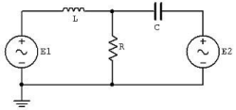

**Figure:1**

**Components:**

* 0 .1 µF Capacitor
* 10mH Inductor
* 1kΩ Capacitor

**Procedure:**

To test the Superposition Theorem, sources E1 and E2 will be examined separately and then together.

**Source One Only:**

* Consider the circuit of Figure 1 with C=0.1 µF, L=10mH, R=1kΩ, using only source E1=2 V p-p at 1 kHz and with source E2 replaced by a 0-V voltage source represented as a short circuit.  Using standard series parallel techniques; calculate the voltages across R. Record the results in  Table 1.
* Build the circuit of Figure 1 using C=0.1 µF, L=10mH, and R=1kΩ. Replace E2 with 0-V  voltage source represented as a short circuit. Set E1 to 2V p-p at 1 kHz, unloaded. Place probe  one across E1 and probe two across R. Measure the voltages across R, and record in Table 1.

**Source Two Only:**

* 3. Consider the circuit of Figure 1 using only source E2=2 V p-p at 10 kHz and with source  E1 replaced by 0-V voltage source represented as a short circuit. Using standard series-parallel  techniques; calculate the voltages across R. Record the results in Table 2.
* 4. Replace the short circuit with source E2 and set it to 2Vp-p at 10 kHz, unloaded. Replace  E1 with 0-V voltage source represented as a short circuit. Place probe one across E2 and probe  two across R. Measure the voltages across R and record in Table 2.

**Source One and Two:**

* + 5. Consider the circuit of Figure 1 using both sources, E1=2Vp-p at 1 kHz and E2=2Vp-p at 10  kHz. Add the calculated voltages across R from Tables 1 and 2. Record the results in Table 3.  6. Replace the short circuit with source E1 and set it to 2Vp-p at 1 kHz, unloaded. Both sources  should now be active. Place probe one across R. Measure the voltages across R, and record in  Table 3.
  + 7. Repeat the experiment for 1uF capacitor, 1mH inductor and 1kΩ.

**Experimental Results:**

**Source One Only**

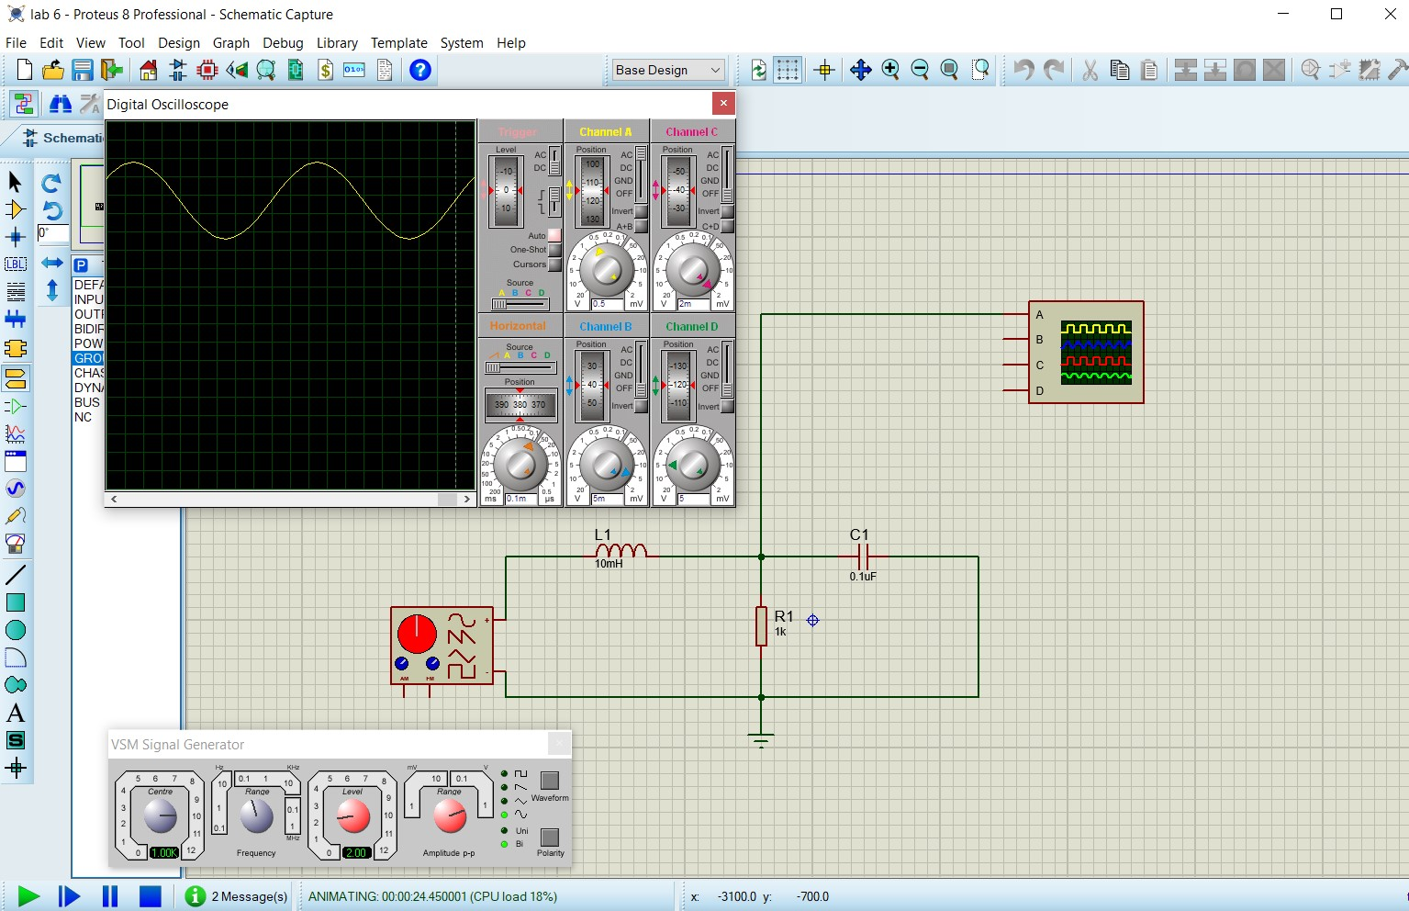

|  |  |  |  |
| --- | --- | --- | --- |
|  | Theoretical | Experimental | % Deviation |
| VR | 2.078V | 2.1V | 1.1% |

**Source Two Only:**

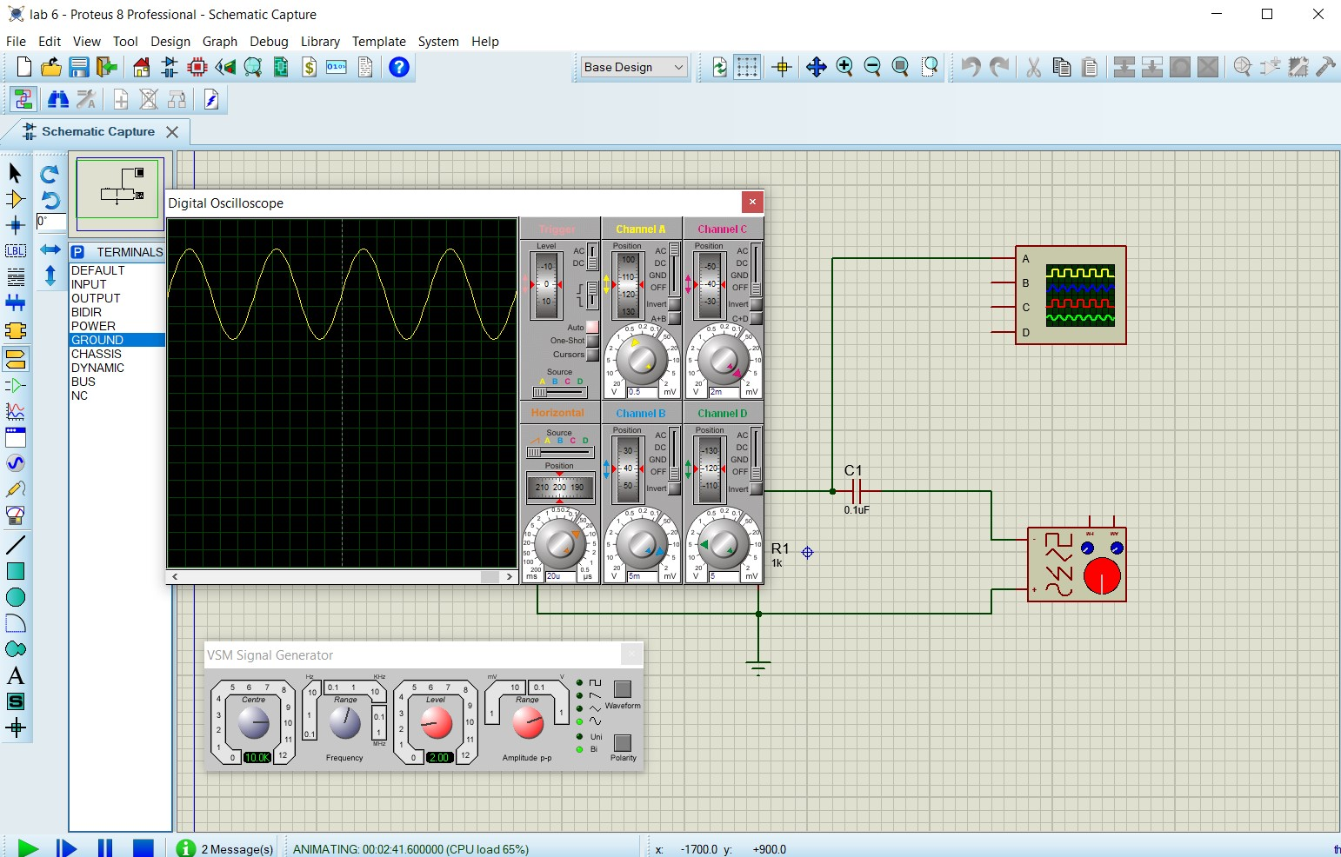

|  |  |  |  |
| --- | --- | --- | --- |
|  | Theoretical | Experimental | % Deviation |
| VR | 2.62V | 2.6V | 0.3% |

**Sources One and Two:**

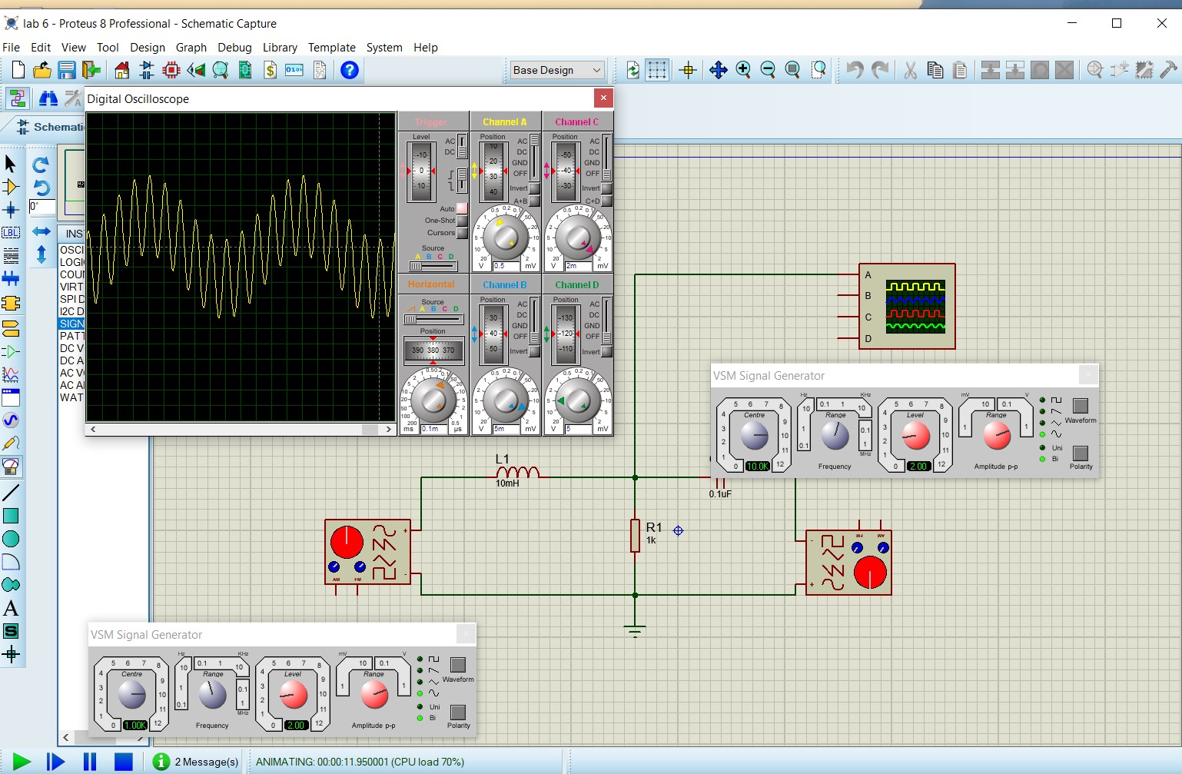

|  |  |  |  |
| --- | --- | --- | --- |
|  | Theoretical | Experimental | % Deviation |
| VR | 4.69V | 4.7V | 0.1% |